**CREATING IBM CLOUD SERVICE**

|  |  |
| --- | --- |
| **DATE** | 08 NOVEMBER 2022 |
| **TEAM ID** | PNT2022TMID52301 |
| **PROJECT NAME** | Fertilizers Recommendation System For Disease Prediction |

**TEAM LEADER: ASWIN R L**

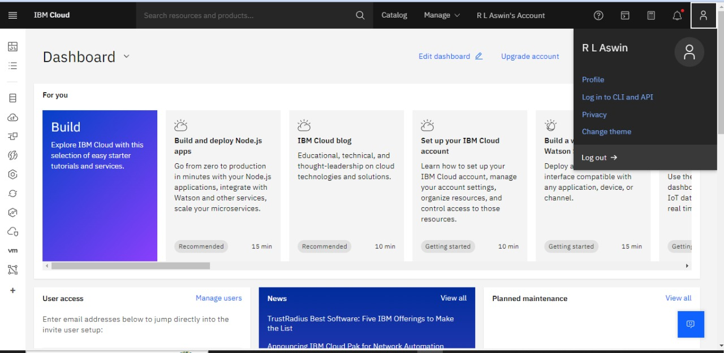

**TEAM MEMBER 1: PRAVIN D**

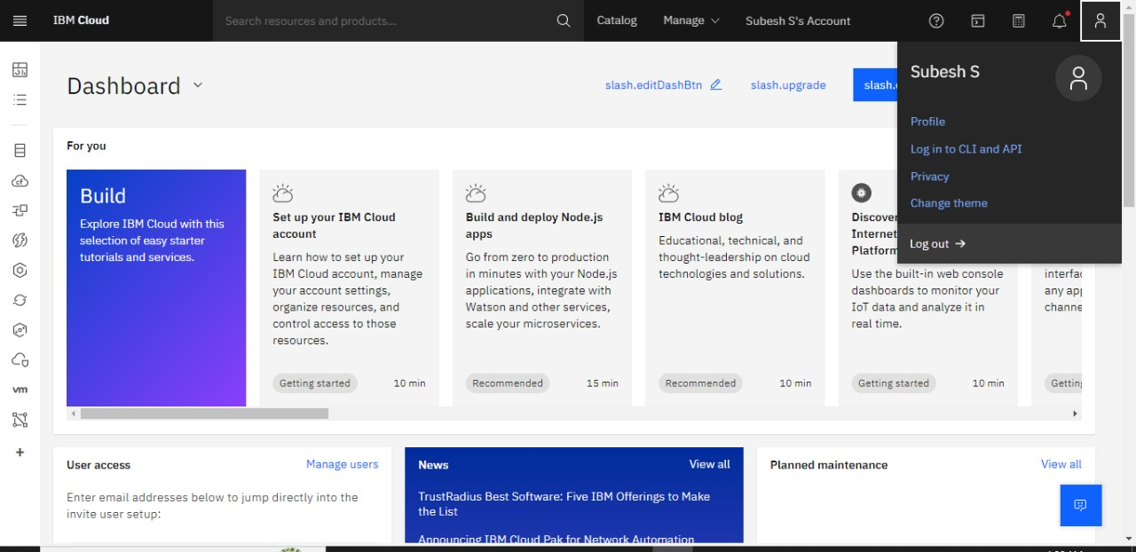

**TEAM MEMBER 2: SUBESH S**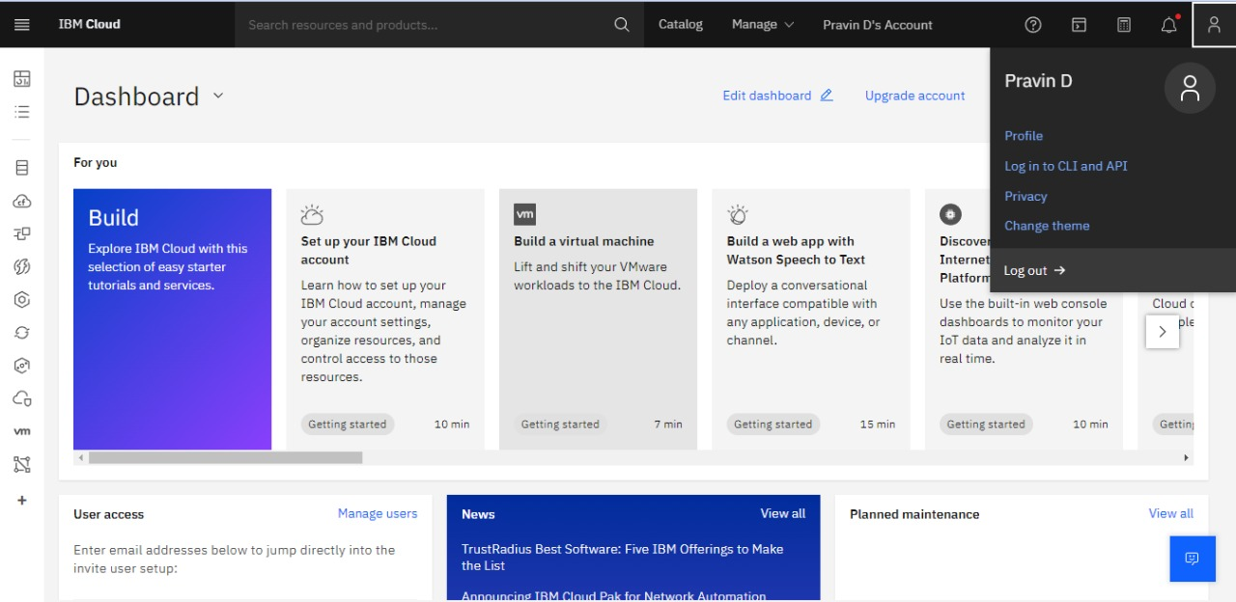

**TEAM MEMBER 4: KESLIN K**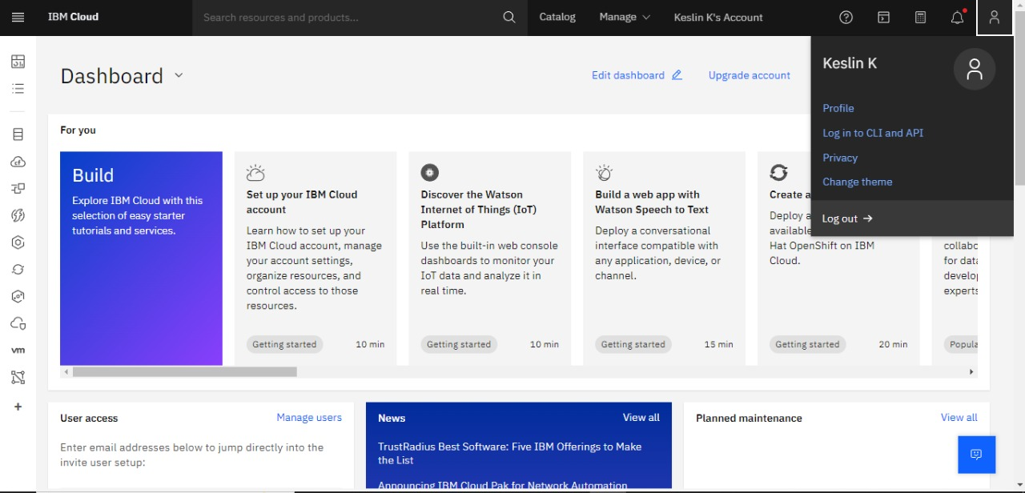

An IBM Cloud Service Created Successfully